introductory patient information
Legal Name |  |  |  | Date
Preferred Name |  |  |  | Phone
DOB |  |  |  | Age
Referral Source |  | Primary Care Physician

Additional Medical Providers
Name | Specialty | Location

Presenting Problem – why are you here today?
In your own words what happened or prompted you to make this appointment? Use the back page if needed.
When did it start? How long has it been going on?
What does it feel like? What makes it better or worse?
Did something trigger a change in health?
When was the last time you felt well?

Current pain scale 1-10
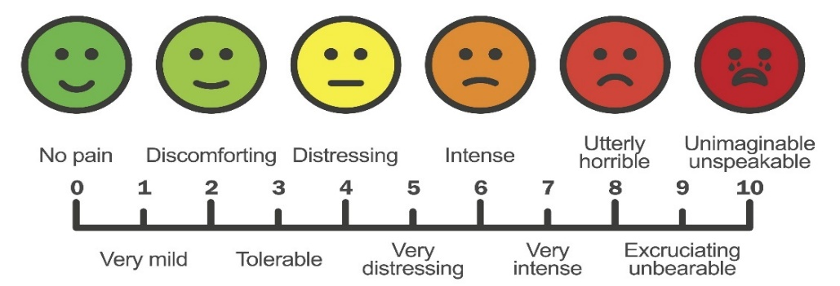

Workers Compensation or Motor Vehicle Claims
Is this visit related to workers comp: Yes ☐ No ☐
Is this visit related to a Motor Vehicle Accident: Yes ☐ No ☐

Other treatments
How often? (Weekly, monthly, occasionally)
Acupuncture
Chiropractic
Massage

Allergies
Name | Reaction

nutritional supplements (vitmains, minerals, herbs)
Name | Dose | Frequency | Start Date | Reason for Use
Please check here and use the back of this form to continue supplement list if needed.

current medications
Name | Dose | Frequency | Start Date | Reason for Use
Please check here and use the back of this form to continue medication list if needed.

prior medication and reason for stopping
Name | Dose | Frequency | Start Date | End Date | Reason for Use and Stopping
Please check here and use the back of this form to medication list if needed

Comprehensive Health Background

Immunization history
 | Date(s) |  |  | Date(s)
Flu shot – influenza |  |  | Pneumonia-13
Tetanus/diphtheria/pertussis |  |  | Pneumonia-23
Meningococcal |  |  | HPV
Measles/mumps/Rubella |  |  | Zoster-Shingles

Current medical problems in order of priority
Name | Severity (Mild/Moderate/Severe) | Prior treatments
Please check here and use the back of this form to continue medication list if needed.

Reproductive history female
Age at menarche (first period |  |  | Date of Last Period
Have you experience menopause, what age? |  |  | Are your periods regular with normal flow?
How many times have you been pregnant? |  |  | How many living children do you have?
How many children born on time? |  |  | How many children born early?
How many miscarriages? |  |  | How many abortions?
How many cesareans? |  |  | How many vaginal deliveries?
How many deliveries required  vacuum or forceps? |  |  | How many deliveries were induced  with medications?

Have you experienced Any of the following?
Postpartum Depression ☐ Toxemia ☐ Gestational Diabetes ☐ Baby over 8 pounds ☐

Reproductive history male
Are both testes descended? Yes ☐ No☐ Do you have or have you ever had a hernia? Yes ☐ No☐

Family history
 | Mother | Father | Sister(s) | Brother(s) | Maternal Grandma | Maternal Grandpa | Paternal Grandma | Paternal Grandpa | Aunt(s) | Uncle(s)
Age if living
Age at Death
Adopted unknown
Asthma
Blood disease
CAD-Heart attack
Cancer-what kind
Crohn’s disease
Dementia
Depression
Diabetes Type 1
Diabetes Type 2
Heart failure
High cholesterol
High blood pressure
Irritable bowel disease
Kidney disease
Obesity
Osteoarthritis
Osteoporosis
Stroke
Substance abuse
Thyroid disease
Ulcerative colitis
Other:

Sexual history

Assigned sex at birth: Select one

Female ☐ Male ☐ Other ☐ Decline to answer ☐

Sexual orientation: Select all that apply
Asexual ☐ Bisexual ☐ Gay ☐ Straight (heterosexual) ☐
Lesbian ☐ Pansexual☐ Queer☐ Questioning/Unsure ☐
Same-Gender Loving ☐ Prefer not to disclose ☐
An identity not listed: please specify ____________________________

Current gender identity: Select all that apply
Female ☐ Male ☐ Gender Queer ☐ Decline to Answer ☐
Transgender Female/Transwoman/MTF ☐ Transgender male/Transman/FTM ☐
Other: please specify ____________

Preferred pronoun(s): Select all that apply
She/her ☐ He/him ☐ They/them ☐ Name Only ☐
Other: please specify ____________

Sexual behavior - Select all that apply
Please describe your sexual activity during the last year:
I was in a monogamous relationship with a man (I had sex with only one man) ☐
I was in a monogamous relationship with a woman (I had sex with only one woman) ☐
I had multiple male partners ☐
I had multiple female partners ☐
I had both male and female partners ☐
I did not have any sexual partners ☐
Other: __________________
Method of birth control if applicable: ______________________
History of STD, Herpes, warts, HPV or other, please explain __________________________
Primary relationships
Single ☐ Married ☐ In a civil union ☐ In a domestic partnership, living together ☐
Partnered not living together ☐ Divorced ☐ Widowed ☐ In a committed relationship ☐
Other: _______________

Social history – check box as applicable with amount used
 | None/never | Daily | Weekly | Yearly | Former/quit date
Tobacco use
Alcohol use
Marijuana use
Caffeine use
 | Sedentary | 2x/week | Moderate | 5x/week | Vigorous
Exercise activity

Dental procedures
Procedure | Date(s) | Duration or number as applicable
Wisdom teeth removal
Other extractions
Braces
Permanent retainer or plates
Removable retainer
Night guard
Implants
Root canal or cavities
Dentures

Surgeries and Procedures
What kind, side if applicable | Date | Why was it done

Hospitalizations
For what | Date(s) | Where

Trauma – any major incident including childhood
How (MVA, falls) | Date(s) or approximate age | What was injured (bone fractures, organs)

General health screening
Date and if result abnormal
Colonoscopy
Dental exam
DEXA scan – bone density
EKG
Endoscopy
Eye exam
Hemoccult
Last full physical
Lipid panel
Mammogram, normal or abnormal ever
PAP, normal or abnormal ever
PSA
Rectal exam
Sigmoidoscopy
Stress test
Urinalysis

review of symptoms
General: No problems ☐ Fevers, Night Sweats, Significant Weight Gain, Significant Weight Loss, Exercise Intolerance
Eyes: No problems ☐ Dry Eyes, Vision Change, Irritation
Ears: No problems ☐ Difficulty Hearing, Ear Pain
Nose: No problems ☐ Frequent Nose Bleeds, Nose Problems, Sinus Problems
Throat: No problems ☐ Sore Throat, Bleeding Gums, Snoring, Dry Mouth, Mouth Ulcers, Oral or Teeth Abnormalities
Heart: No problems ☐ Chest Pain, Arm Pain on Exertion, Shortness of Breath when Walking, Shortness of Breath when Lying Down, Palpitations, Known Heart Murmur
Lungs: No problems ☐ Cough, Wheezing, Shortness of Breath, Coughing Up Blood, Sleep Apnea, Sputum Production
Stomach/Bowels: No problems ☐ Abdominal Pain, Nausea, Vomiting, Constipation, Abnormal Appetite, Diarrhea, Vomiting Blood, Dyspepsia, GERD, Difficulty Swallowing, Bowel Movement Changes, Rectal Bleeding
Genitourinary: No problems ☐ Incontinence, Difficulty Urinating, Hematuria, Increased Frequency
Female: No problems ☐ Abnormal Bleeding, Flank Pain, Trouble Urinating, Rash, Lesion, Discharge, Vaginal Odor or Itching
Musculoskeletal: No problems ☐ Muscle Aches, Muscle Weakness, Arthralgia/Joint Pain, Back Pain, Swelling in Extremities
Skin: No problems ☐ Abnormal Mole, Jaundice, Rashes, Laceration
Neurologic: No problems ☐ Loss of Consciousness, Weakness, Numbness, Seizure, Dizziness, Migraines,
Headaches, Tremor
Psychiatric: No problems ☐ Depression, Sleep Disturbance, Feeling Safe in Relationship, Alcohol Abuse, Anxiety, Hallucinations, Suicidal Thoughts
Endocrine: No problems ☐ Fatigue, Menstrual Problems, PMDD, Menopausal, Sexual Problems
Blood/Lymph: No problems ☐ Swollen Glands, Bruising, Excessive Bleeding
Allergic/Immunity: No problems ☐ Runny Nose, Sinus Pressure, Itching, Hives, Frequent Sneezing

All of the above items were reviewed with the patient by the physician and are confirmed as noted above and documented in the medical record.
Dr. Rosendahl ______________________________________ Date ________________

