introductory patient information
Legal Name |  |  |  | Date
Preferred Name |  |  |  | Phone
DOB |  |  |  | Age
Referral Source |  | Primary Care Physician
School |  | Grade
Person Filling  out Form |  | Relationship to Patient

Additional Medical Providers
Name | Specialty | Location

Presenting Problem – why are you here today?
In your own words what happened or prompted you to make this appointment? Use the back page if needed.
When did it start? How long has it been going on?
What does it feel like? What makes it better or worse?
Did something trigger a change in health?
When was the last time the patient felt well?

Current pain scale 1-10
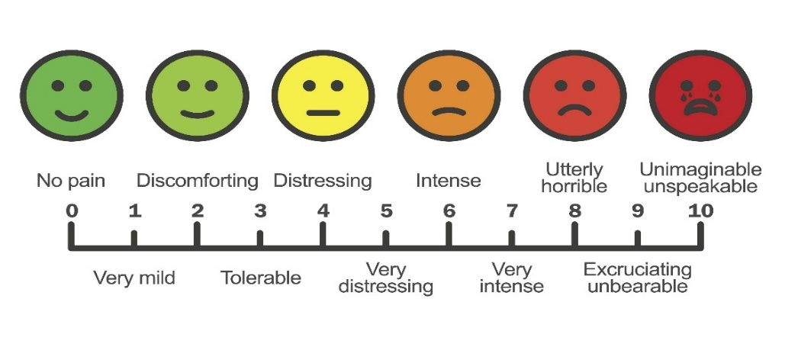

Motor Vehicle Claims
Is this visit related to a Motor Vehicle Accident: Yes ☐ No ☐

Allergies
Name | Reaction

nutritional supplements (vitmains, minerals, herbs)
Name | Dose | Frequency | Start Date | Reason for Use
Please check here and use the back of this form to continue supplement list if needed.

current medications
Name | Dose | Frequency | Start Date | Reason for Use
Please check here and use the back of this form to continue medication list if needed.

prior medication and reason for stopping
Name | Dose | Frequency | Start Date | End Date | Reason for Use and Stopping
Please check here and use the back of this form to medication list if needed

Comprehensive Health Background

Current medical problems in order of priority
Name | Severity (Mild/Moderate/Severe) | Prior treatments

Dental procedures
Procedure | Date(s) | Duration or number as applicable
Wisdom teeth removal
Other extractions
Braces
Permanent retainer
Removable retainer
Night guard
Implants
Root canal or cavities

Family history
 | Mother | Father | Sister(s) | Brother(s) | Maternal Grandma | Maternal Grandpa | Paternal Grandma | Paternal Grandpa | Aunt(s) | Uncle(s)
Age if living
Age at Death
Adopted unknown
Allergies
Asthma
Blood disease
CAD-Heart attack
Cancer-what kind
Crohn’s disease
Dementia
Depression
Diabetes Type 1
Diabetes Type 2
Heart failure
High cholesterol
High blood pressure
Irritable bowel disease
Kidney disease
Obesity
Osteoarthritis
Osteoporosis
Stroke
Substance abuse
Thyroid disease
Ulcerative colitis
Other

Surgeries and procedures
What kind, side if applicable | Date | Why was it done

Hospitalizations
For what | Date(s) | Where

Trauma – any major incident
How? (MVA, falls) | Date(s) or approximate age | What was injured (bone fractures, organs)

General health screening
Date and if result abnormal
Dental Exam
Eye Exam
Last Full Physical

Perinatal history: Choose those that apply
Pregnancy Complications in mom
Toxemia |  |  | Illness
Threat of Miscarriage |  |  | Infection
Hospitalizations |  |  | Operation

Full-Term ☐ // Premature: # of weeks ☐_______ // Birth Weight/Length _____________________
Type of Labor
Spontaneous ☐ // Induced ☐ // Duration (hours) ________

Type of Delivery
Normal ☐ // Breech ☐ // Caesarean ☐ // Forceps ☐ // Vacuum ☐ // Apgar Scores __________

Complications
Cord around neck ☐ // Hemorrhage ☐ // Infant injured during delivery ☐ // Other___________________

Post delivery period
Jaundice ☐ // Cyanosis (turned blue) ☐ // Incubator ☐ // Infection ☐

Number of days infant was in hospital after delivery, due to infant’s condition: _______
Breast fed for how long? ________________ Bottle fed for how long? _________________

Infancy: Were any of the following present? Chose all that apply
Colic / Fussy ☐ Reflux / Vomiting ☐ Difficulty Feeding ☐

coordination & Milestones
As a toddler and into childhood | More than average  Good | Average | Less than average  Poor
Walking
Running
Athletic Abilities
Hand Writing
Clumsiness
Milestones | Early | Normal | Late
Rolled over
Sat up
Crawled
Walked
Toilet Trained

interests

Hobbies and Interests? Comments? Is there anything we need to know that we haven’t already asked?

review of sySTEMS
General: No problems ☐ Fevers, Night Sweats, Significant Weight Gain, Significant Weight Loss, Exercise Intolerance
Eyes: No problems ☐ Dry Eyes, Vision Change, Irritation
Ears: No problems ☐ Difficulty Hearing, Ear Pain
Nose: No problems ☐ Frequent Nose Bleeds, Nose Problems, Sinus Problems
Throat: No problems ☐ Sore Throat, Bleeding Gums, Snoring, Dry Mouth, Mouth Ulcers, Oral or Teeth Abnormalities
Heart: No problems ☐ Chest Pain, Arm Pain on Exertion, Shortness of Breath when Walking, Shortness of Breath when Lying Down, Palpitations, Known Heart Murmur
Lungs: No problems ☐ Cough, Wheezing, Shortness of Breath, Coughing Up Blood, Sleep Apnea, Sputum Production
Stomach/Bowels: No problems ☐ Abdominal Pain, Nausea, Vomiting, Constipation, Abnormal Appetite, Diarrhea, Vomiting Blood, Dyspepsia, GERD, Difficulty Swallowing, Bowel Movement Changes, Rectal Bleeding
Genitourinary: No problems ☐ Incontinence, Difficulty Urinating, Hematuria, Increased Frequency
Female: No problems ☐ Abnormal Bleeding, Flank Pain, Trouble Urinating, Rash, Lesion, Discharge, Vaginal Odor or Itching
Musculoskeletal: No problems ☐ Muscle Aches, Muscle Weakness, Arthralgia/Joint Pain, Back Pain, Swelling in Extremities
Skin: No problems ☐ Abnormal Mole, Jaundice, Rashes, Laceration
Neurologic: No problems ☐ Loss of Consciousness, Weakness, Numbness, Seizure, Dizziness, Migraines,
Headaches, Tremor
Psychiatric: No problems ☐ Depression, Sleep Disturbance, Feeling Safe in Relationship, Alcohol Abuse, Anxiety, Hallucinations, Suicidal Thoughts
Endocrine: No problems ☐ Fatigue, Menstrual Problems, PMDD, Menopausal, Sexual Problems
Blood/Lymph: No problems ☐ Swollen Glands, Bruising, Excessive Bleeding
Allergic/Immunity: No problems ☐ Runny Nose, Sinus Pressure, Itching, Hives, Frequent Sneezing

All of the above items wILL BE reviewed with the patient by the physician and are confirmed as noted above and documented in the medical record.
Dr. Rosendahl ______________________________________ Date ________________

