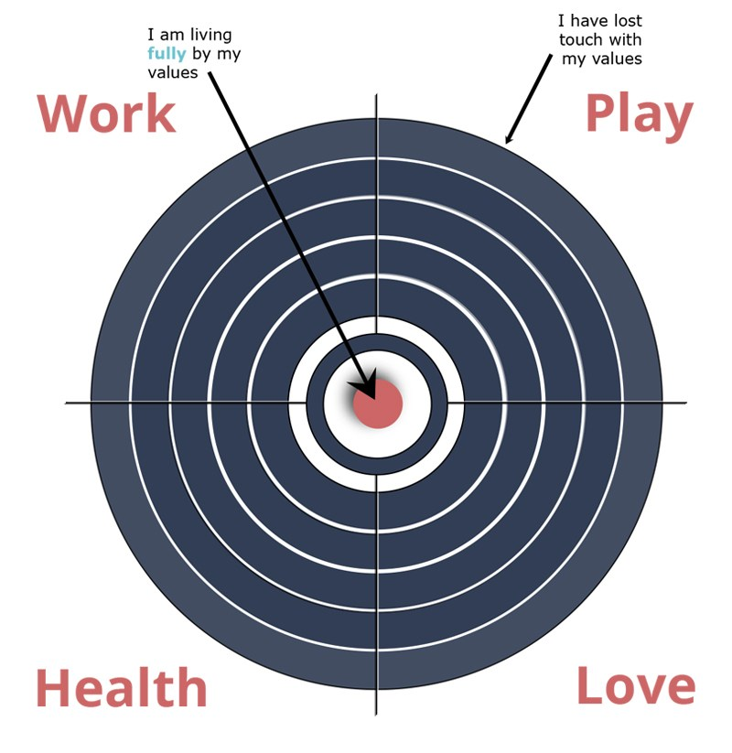

- Where has my mood been? (whats on the target and what is drifting)
- Where have I been most consistent?
- Where have I been “struggling”?
- What do I want to do about marks that are “drifting”?

